The Cynefin Framework
David Snowden, The Cognitive Edge
Understanding an industry’s context and its competitive environment is a highly complex task. Decisions must be made with less than perfect knowledge, and often including highly dynamic variables, especially when technological disruption is likely to upend long held assumptions. David Snowden proposes a decision framework for senior strategists and marketers.
David Snowden, the complexity thinker, notes that when we are confronted with contexts and situations when we need to decide and act, “ … we will interpret the situation according to our personal preference for action” (Snowden, 2010).
To address this, The Cynefin Framework “gives us a very easy way of deciding how to work but it [also] gives us a divergent [way of thinking] - we sometimes call this requisite applicability. It basically says dependent on which space you’re in you should think differently, should analyze differently, rather the one-size-fits-all which has been a tradition of management theory” (Snowden, 2010).

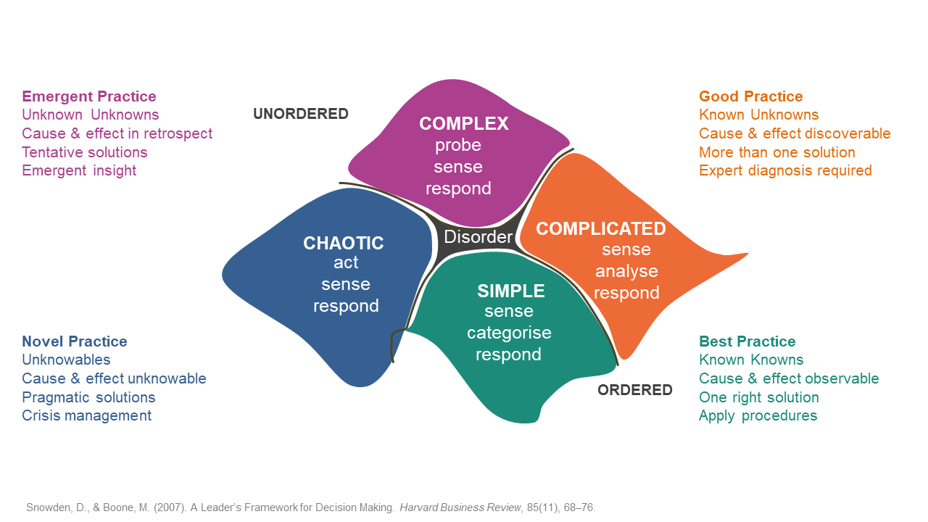
Action
Watch the Cynefin Decision framework video presented by David Snowden https://youtu.be/N7oz366X0-8 and read the transcript provided. Consider where in the decision framework the set of decisions you need to make, should fit. Consider the likely mindset of the organisations that would potentially be making these long term strategic decisions. Ponder this for a moment. f
As you watch the video, listen carefully for the nuances about each space, and be careful about the ‘cliff space’ between Simple and Chaotic.
Consider your observations and reactions in the context of your current, and perhaps, past situations of decisions making, actions and outcomes.
Ponder these questions
- Does the framework add to your understanding of how people, teams and organisations
‘get things done’?
- How might you use this complexity decision framework in your own work?
- Think about your own view of the world. What is your default approach to issues and decision situations?
- Think about how you might share with your immediate team your insights and preferences.
How might you deal with these in your work context? What impact will your preferences,
and those of others, have on the outcomes?
References
Snowden, D. , & Boone, M. (2007). A Leader’s Framework for Decision Making. Harvard Business Review, 85(11), 68-76.
Snowden, D. [CognitiveEdge]. (2010, July, 11). The Cynefin Framework [Video file]. Retrieved from
https://youtu.be/N7oz366X0-8

