Boyatzis and SECI: How they fit and how they relate to the story of continuous improvement!

The Idea:
Richard Boyatzis and his colleagues have worked on the powerful concept of coaching for change. The theory of Intentional Change is the foundation of the model we will use with and your peers. Just know that we at QUTeX have adapted the model so that it focuses as much on your team and your team’s growth as it does on your individual growth.
The underpinning of the model is that intentional change involves envisioning the ideal self – for you this means a broader view to encompass your team and your division. This idea of what to do and be in terms of success, builds on the ‘now’, where we currently are and what we need to do to get to where we want to be.
When you look at the model you will see that there are specific stages and thinking mindsets. When you look at the centre of the model, you will see that developing trust is at the core. This is where the power of coaching really comes to play.
Coaching is a powerful component of building this awareness and sharing the nature and scope of the ideal, the future. It supports the learning agenda and sets up for the practicing stage of the new behaviours and embedding and delivery on the capability. The fundamental element however is that trust building.
Here is a visual the original model of the Theory of Intentional Change.
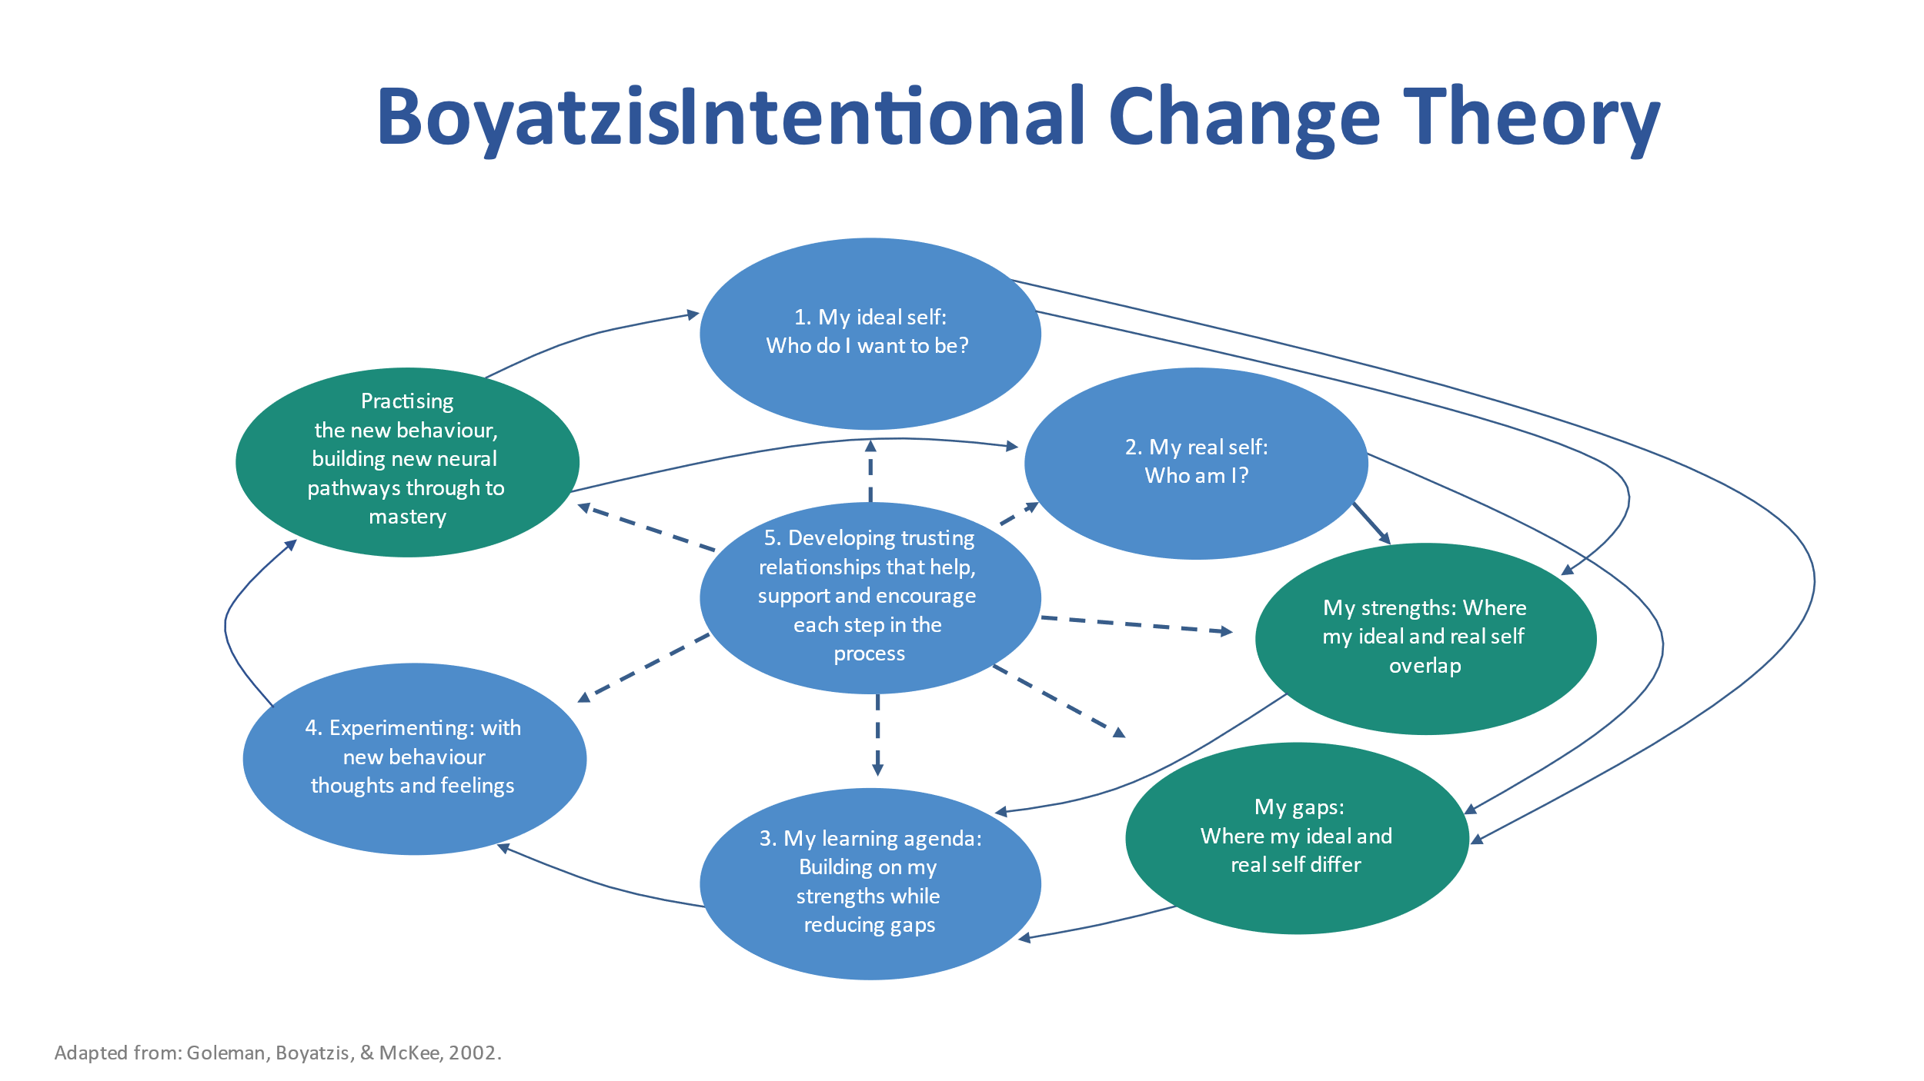
Goleman, Boyatzis, & McKee, 2002. Intentional Change Theory

Here is a visual the modified model of the Theory of Intentional Change that we will use as the foundation of the learning model for your group learning and change models and for you to use as you embed capability in your teams.
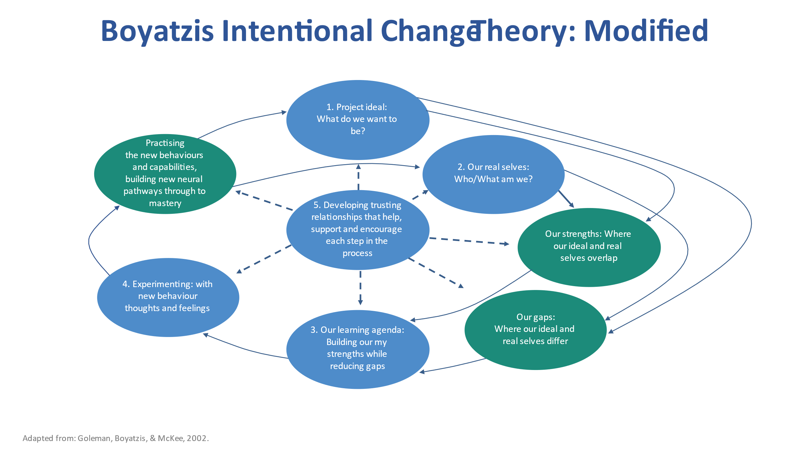
Adapted from: Goleman, Boyatzis, & McKee, 2002. Intentional Change Theory modified for Group Practice.
After you practice in the workshop and learn new skills and ways of working and creating, around your customer focus, we will work with you on a model that you can use to continue to experiment and grow.
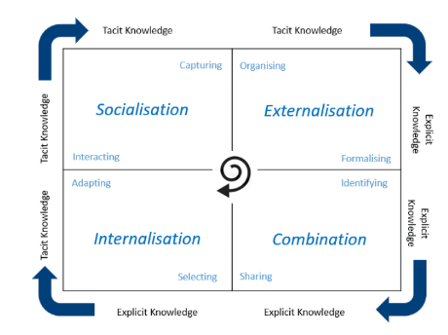
The SECI Model
Intentional Change and SECI are both learning and implementation models that are useful processes for continuous growth. Behind the concept of intentional change is a psychological model that can help us every day, especially when we want everyone around us, to learn from what we are learning and doing that contributes to our successes.
Ikujiro Nonaka has dedicated his life to understanding how we create and use knowledge in teams and in our organisations. Along with his fellow researcher, Hirotaka Takeuchi, he has developed the SECI process.
SECI stands for: Socialisation, Externalisation, Combination, Internalisation.
Think of SECI as a spiral with 4 sections that feed on each other and each ‘turn’ of the spiral helps the next turn.
Here is an explanation of the sections. Before you start however you need to know a bit more about two of the concepts. These are tacit knowledge and explicit knowledge.
Tacit knowledge is the stuff we just know and know how to do. It is experience and intuition. Riding a bike or playing a piece of music are examples of tacit knowledge. They are things that become innate with experience. In the workplace we learn how things work, how to do things, we develop ‘work arounds’ for problems and challenges. Not everyone knows these things or even knows of them. However, the knowledge is there and is evident in the way things are done.
Explicit knowledge, on the other hand, is formalised, shared in a structured way and can be stored, transmitted or transferred. It is accessible and can be understood outside individual experience and knowledge. People know how to find and how to use it. It is in training sessions, in guides and manuals and there are others we can go to who can show and tell the ‘right’ way.
The SECI model shows how both tacit and explicit knowledge can, in different ways, create new knowledge when it is shared. The process of learning can continue to spiral, creating further new knowledge. It is an illustration of how new knowledge emerges when we put knowledge into action.
This knowledge creation and sharing model is one of the foundations of Lean Thinking. The outcome is a capability set that enables the organisations and its teams to do what they need to do to be successful.
Here are the details of the components of the SECI model.
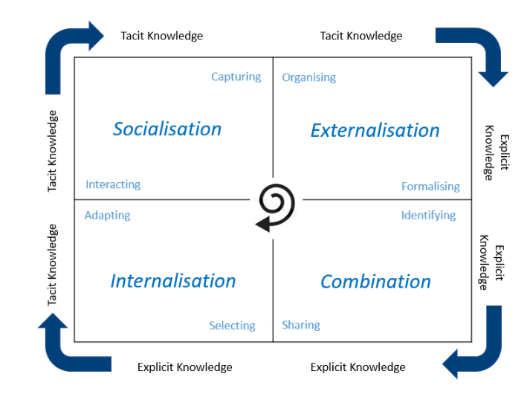

These knowledge types are the inputs to the Socialisation-Externalising-Combination-Internalisation (SECI) model. The SECI model is the process by which the knowledge is turned into capability and expertise.

Socialisation
Colleagues can share their tacit knowledge with one another ‘socially’, typically face to face or virtually, through interaction. Typically, this sharing is informal rather than structured, Practice tends to also informal. We watch and learn. At times however, the tacit knowledge stays with the individual who developed this new way of doing things. This is leads to the E of the SECI model. Capturing is the element of socialisation that enables the progress to the next step in the process.
Externalisation

Taking tacit knowledge and creating explicit knowledge means it can be readily accessed, understood, and applied by others. Organising is the element of externalisation that enables the creation of explicit knowledge.
The benefit of externalisation is not only that the existing knowledge has been surfaced and shared more widely, but it can also now be used as a base for creating further knowledge. For leaders and team members, the externalisation process can be valuable as an exercise in surfacing what is known and not (yet) known.
It is powerful for testing knowledge against assumptions. It links individual tacit knowledge with broader knowledge bases. Understanding the process and importance of externalisation helps those who have tacit knowledge to share it. Teams and organisations that value new knowledge and focus on Lean thinking encourage and reward the sharing of tacit knowledge when it becomes a part of the bigger knowledge set. Formalisation is the element of externalisation that enables the knowledge to be carefully structured to be considered in the combination phase of the SECI spiral.
Combination
One of the ways explicit knowledge can be leveraged to create new knowledge is when it is shared and combined with other existing, explicit knowledge. Identifying is the element of combination that highlights the valuable and useful knowledge in the organisation’s knowledge and capability sets. In the combination stage of SECI the synthesis and creation of the ‘new’ takes place.
However, without sharing and socialisation the new knowledge is wasted. This is where so much valuable knowledge and learning goes to die!
Internalisation
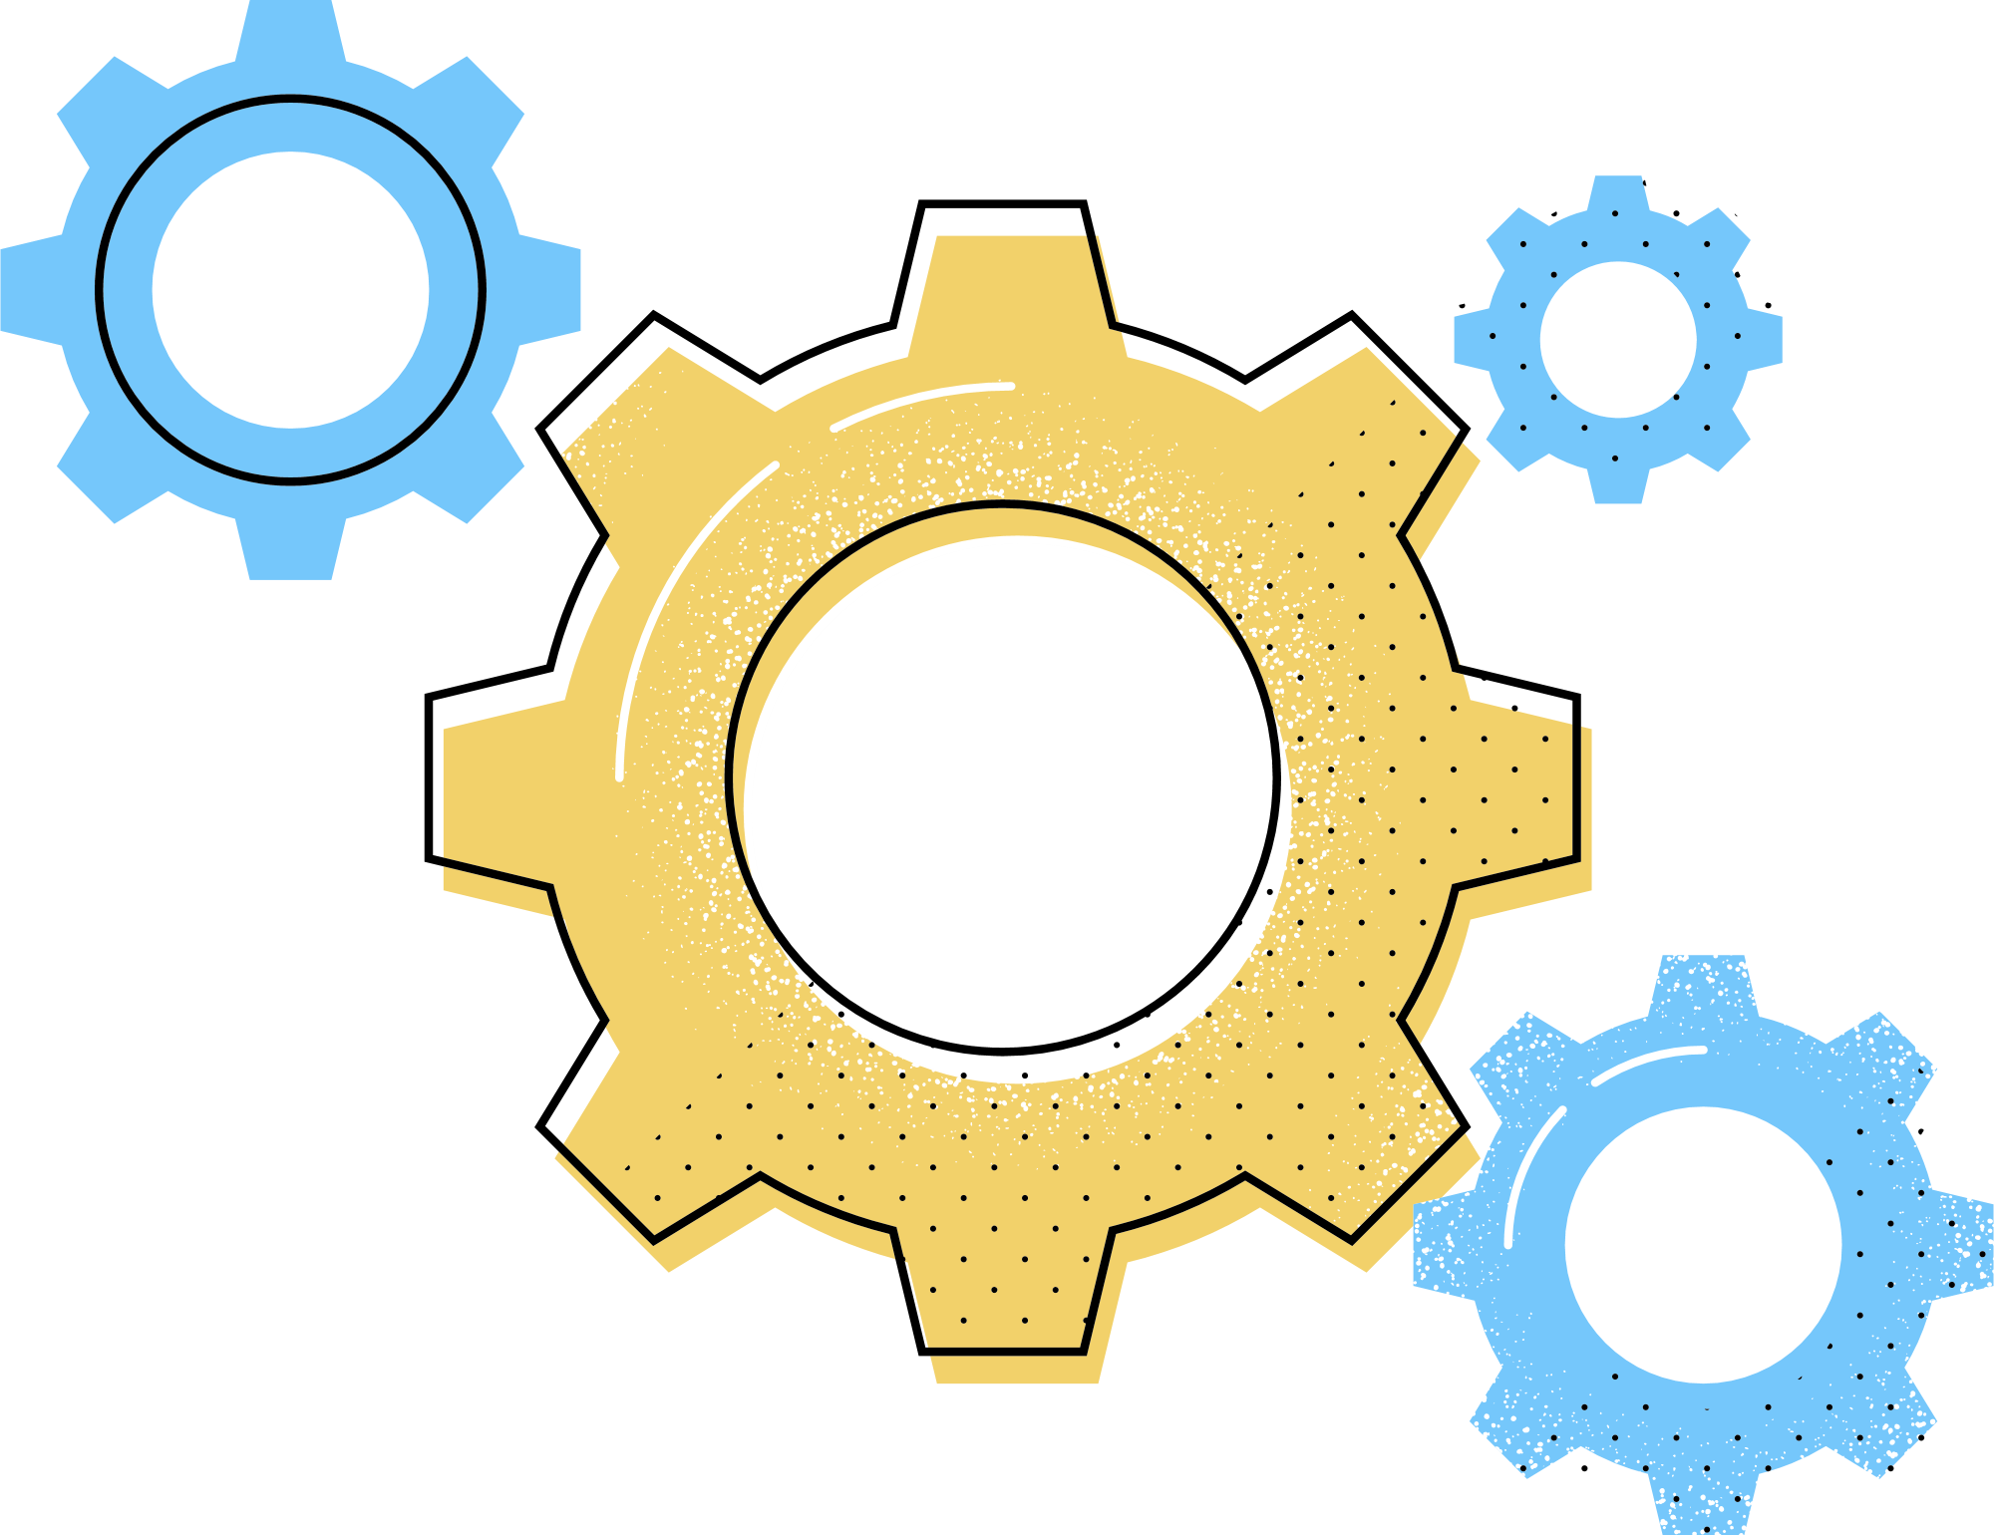
Many learning experiences include periods of uncertainty, awkwardness, even confusion. Once new knowledge becomes internalised it becomes more comfortable. Selecting is essential here. What matters and is of value and can be used and leveraged?
The valuable new knowledge moves from being explicit to being tacit. It becomes a part of what we do, what we are great at, and what moves us to the next level of performance.
Like the piano student who struggled to learn their scales but now plays a sonata without consciously thinking of the notes or finger movements or like the new recruit who didn’t recognise any of the systems in your workplace or understand their roles but is now a highly functioning team member.
Internalised knowledge forms a base for new experiences and knowledge to be gained and hopefully shared if the knowledge spiral is encouraged.
As the internalised knowledge is applied and its users begin to review, reflect and adapt, the users of the knowledge share it in the process of socialisation, and so the SECI process continues in a virtuous cycle.
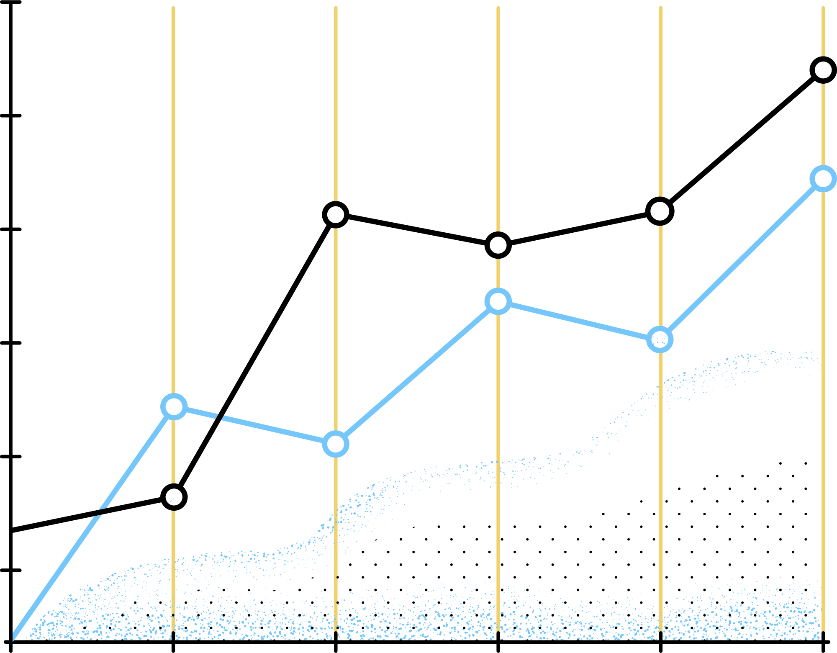
And that is the story of continuous improvement!
This spiral of knowledge creation and continuous improvement can occur at many levels of an organisation. It can occur between individuals, whether they are peers, officers and direct reports, or mentors. It can occur within and between teams and barracks. It can occur within the individual. The larger the scope of the spiral the greater the potential impact of the knowledge creation process.

Nonaka, I., & Takeuchi, H. (2011). The wise leader. Harvard business review, 89(5), 58-67, 146.
Peloso, A., & Warren, A. (2020). Strategist. Coach. Strategy as Knowledge in Action. QUT.
Nonaka, I., Toyama, R., & Konno, N. (2000). SECI, Ba and Leadership: a Unified Model of Dynamic Knowledge Creation. Long range planning, 33, 5-34. https://doi.org/10.1016/S0024-6301(99)00115-6

